**Worksheet 2**

**Core Computing Concepts for Cyber Security**

**Exploring Graph Theory**

**13/10/2023**

**Student Number: 2206377**

**Introduction**

Graph theory is a fundamental branch of mathematics that studies relationships and connections. In this worksheet, we will delve into various aspects of graph theory, from basic definitions to exploring some applications. By the end, you will have a better understanding of graph theory and its practical uses.

**Investigation 1: What is a graph?**

**Definition**

**Nodes & Edges**

**Investigation 2: Types of Graphs**

**Directed & Undirected**

**Weight & Unweighted**

**Investigation 3: Degrees and Nodes**

**Degree of a node**

**Degree Sequence**

**Investigation 4: Paths & Cycles**

**Paths**

**Cycles**

**Classic Graph Theory Problems**

In this investigation, we'll explore several classic problems in graph theory. These problems provide valuable insights into the world of graphs and their practical applications. Research the problem

**Investigation 5: The Three Houses and Three Utilities Problem:**

**Problem Introduction:**

You are given three houses and three utilities (A, B, and C). Your task is to connect each house to all three utilities without allowing any of the connection lines to cross each other.

**Graph Representation:**

Think of this challenge as a graph.

**Nodes (Vertices**): Each house and each utility is represented as a node or vertex in the graph.

* House 1 is a node labeled H1.
* House 2 is a node labeled H2.
* House 3 is a node labeled H3.
* Utility A is a node labeled A.
* Utility B is a node labeled B.
* Utility C is a node labeled C.

**Edges (Connections)**: The edges of the graph represent the connections between houses and utilities. There should be a total of nine edges (three for each house).

**Your Task:**

Each house must be connected to all three utilities (A, B, and C). No lines representing these connections are allowed to cross each other. This means that the graph should be planar, meaning it can be drawn on a flat surface without any edge intersections.

**Investigation 6: The Konigsberg Bridge Problem**

**Problem Background:**

Königsberg was a city located on both sides of the Pregel River, with two large islands connected to each other and the mainland by seven bridges.

The problem is to find a walking route that crosses each bridge exactly once and returns to the starting point.

**Graph Representation:**

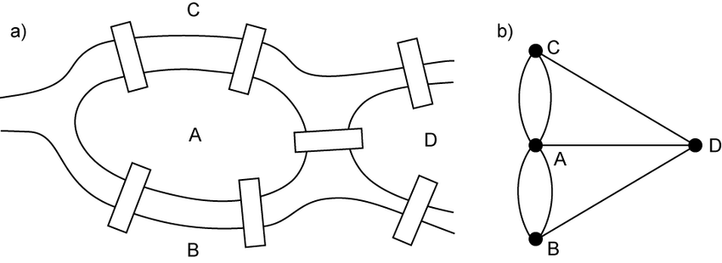

**Nodes (Vertices)**: In graph theory, we represent land masses as nodes or vertices. In the case of Königsberg, we have four land masses: A, B, C, and D. Each of these land masses is a node.

**Edges (Connections)**: The edges of the graph represent the bridges connecting these land masses. Each of the seven bridges is an edge connecting two nodes.

**Conditions:**

The task is to find a continuous path (walk) that crosses each bridge exactly once and returns to the starting point. The path must not retrace any part of the path previously travelled. You cannot backtrack or retrace any part of your path. Your goal is to determine if it's possible to find such a path or if it's not possible.

**Analysis:** Analyse the paths you explore to determine whether any of them satisfy the conditions. Think critically about whether a path can be found that crosses all seven bridges without repeating any segments.

The Königsberg Bridge Problem is famous because it led to the development of graph theory concepts like Eulerian paths and circuits. Euler's solution to this problem laid the foundation for solving similar problems in graph theory, making it a significant historical puzzle in the field.

**Part 4: Investigating Dijkstras Algorithm**

**Algorithm Implementation**

**Complexity Analysis**

**Investigation 9: Djikstra’s Algorithm in Action**

**Practical Example**

**Real-World Significance**

**Conclusion**